Problem Set 6
Due: Wednesday, March 12th

Please complete the following exercises.

Some kind of simple recurrence relation?

An equivalence relation is one that is reflexive, symmetric, and transitive. For each of the following indicate whether the relation is an equivalence relation and, if not, indicate which property is violated. For example, the less-than-or-equal relation is not an equivalence class because even though it is reflexive and transitive, it is not symmetric (that is, a < b does not mean that b < a).

- EvenProduct(x,y) where x and y are natural numbers and the relation holds when x∙y is an even natural number.
- Connected(x,y) where x and y are nodes in a graph and the relation holds when there is a path from x to y. Note that a node has a path of length zero to itself.
- Reciprocals(x,y) where x and y are rational numbers and the relation holds if
x∙y = 1.
- Subset(A,B) where A and B are sets and the relation holds when A is a subset of B.
In the following maze, the idea is start where the S is and to finish where the F is. Draw the maze as a tree. Begin by labeling every dead end with the letters A, B, …. Then mark each point where a decision can be made. Label those points with the numbers 1, 2, …. Note that in some places, one can go three different ways.
The numbered points become internal nodes in the tree. The lettered points become leaf nodes, as does the finish point.
For example, just to the right of the S is a point where one can either continue to the right or one can go down. That point is the root node of the tree and is labeled “1”. That node has two children. The right child is the next decision point found by continuing to the right. The left child is the next decision point found by going down (which will be a place where one can go three different directions).
The following graph is called the tetrahedral graph.
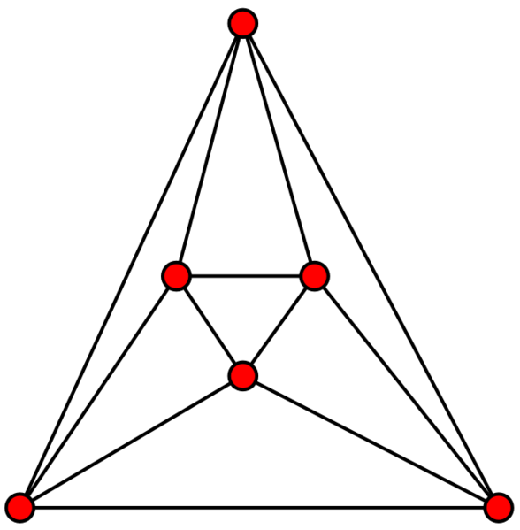
- Trace an Euler cycle on it starting with the node at the top.
- Can you color it with two colors? If not, why not?
- Can you color it with three colors? If so, show a coloring using the colors brown (B), purple (P), and orange (O).
The following graph is called the Peterson graph.
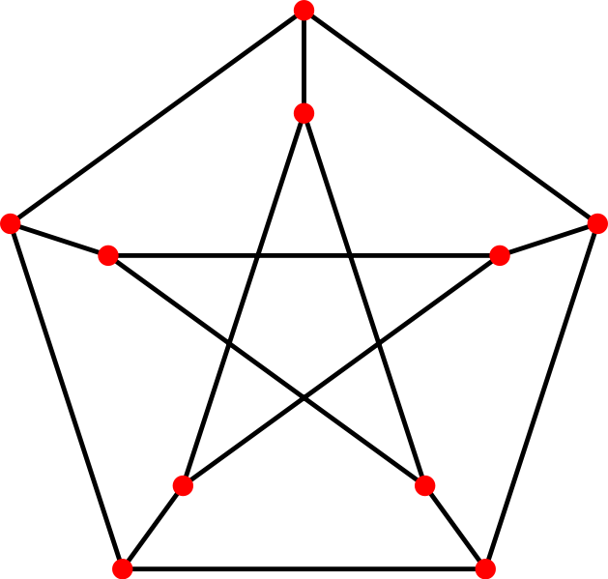
- Does this graph have an Euler cycle? Why or why not?
- Does it have a Hamiltonian cycle? If so, trace it starting with the node at the top.
- Can you color it with two colors? If not, why not?
- Can you color it with three colors? If so, show a coloring using the colors brown (B), purple (P), and orange (O).

